1. **COMPANY FINANCIALS ANALYSIS**

**INTRODUCTION**

The following project is about a company’s financial analysis . The data set was acquired from Kaggle and in contains 700 rows of data. Data cleaning and preprocessing was done in Excel saved as Financial- Copy in the github repo while the cleaned dataset is labelled Financials as a csv file. The data was imported into MySQL for querying of business questions and using ODBC connector , the data was connected into Power B for visualization and dashboard creation.

**BUSINESS QUESTIONS AND FINDING**

1. What is the total revenue for the year/month/quarter?

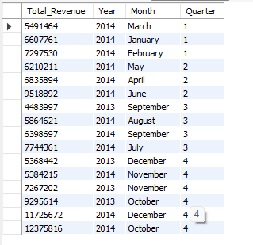

1. How has net profit evolved over time (trend)?

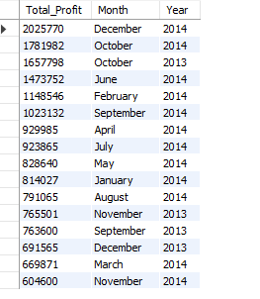

1. What is the profit margin (%) and how does it vary by product or department?

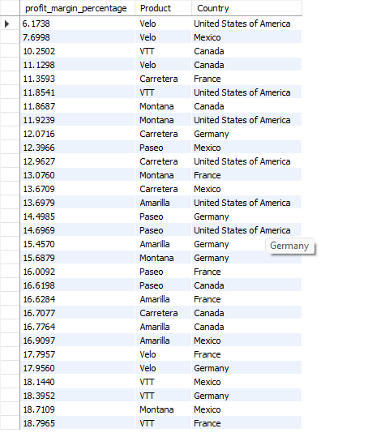

1. What is the YoY or MoM revenue growth rate?

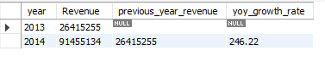

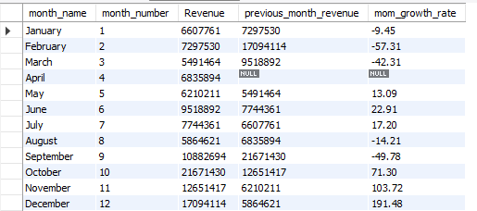

1. Which months or quarters were the most/least profitable?

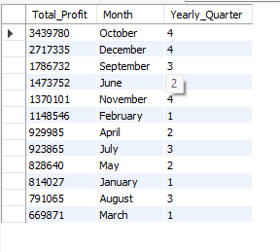

1. What are the top 10 products or services by revenue?

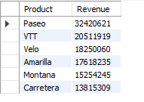

1. Which customers or segments generate the most revenue?

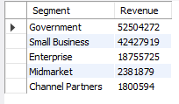

1. What is the average sales value per transaction?



1. What is the revenue breakdown by region or sales channel?

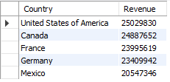

1. Is there a correlation between expenses and revenue growth?



1. What is the gross profit per product/service?

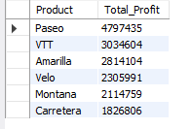

1. Which products have the highest/lowest profit margins?

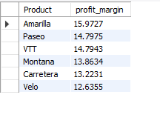

The data was then connected to Power Bi for visualization and dashboarding implementing DAX functions and various charts .

